Reliance Foundry Co Ltd
#207-6450 148 St
Surrey, BC V3S 7G7
Phone: 604-547-0460
Phone: 1-877-789-3245
Fax: 604-590-8875
Email: info@reliance-foundry.com
Website: www.reliance-foundry.com

Reliance Foundry is an award-winning supplier of high quality stock and custom-designed site furnishings
for architectural, traffic management, and industrial applications. Reliance Foundry brings over 90 years of expertise to the design and manufacturing of our products.

Reliance Foundry bicycle racks and bike parking bollards increase cyclist access and security, prevent damage to trees and other streetscape features, and promote sustainable lifestyles in your community.
This section includes bicycle racks.

Specification Coordination: Edit this guide specification to meet project requirements. Coordinate with other specification sections as required. If using more than one bollard type, use the same designation in both drawings and specifications. Display hidden text to see or print notes to specifier.

Drawing Coordination: Show locations, sizes, layout, and spacing of each type of bollard or bollard cover required. Show footing and security post details, if required. Soft metric conversion is provided for all measurements.

SECTION 12 93 13
BICYCLE RACKS

- GENERAL
      - SUMMARY
        - Section Includes: Bicycle racks.
        - Related Requirements:
          - Section 32 39 13.13 – Metal Bike Parking Bollards
See http://www.reliance-foundry.com/bike-storage for metal bike parking bollard specifications.
      - REFERENCES
        - Reference Standards:
          - AAMA 2603 – Pigmented Organic Coatings on Aluminum Extrusions and Panels.
          - ASTM A36 – Carbon Structural Steel.
          - ASTM A53 – Pipe, Steel, Black and Hot-Dipped, Zinc-Coated, Welded, and Seamless.
          - ASTM A312 – Seamless, Welded, and Heavily Cold Worked Austenitic Stainless Steel Pipes.
          - ASTM A959 – Harmonized Standard Grade Compositions for Wrought Stainless Steels.
      - ACTION SUBMITTALS
        - Manufacturer's Product Data.
Delete paragraph below if specifying colors in this section or in Drawings.
        - Samples for Initial Selection: Color card of manufacturer's standard colors.
        - Samples for Verification: Specified finish.
Reliance's bicycle storage units may contribute to these and other LEED credits. Adjust list below to reflect credits sought for the project.
Credits below are based on LEED 2009 New Construction, Core and Shell, and Schools rating systems.
        - LEED Submittals:
          - Credit SS 4.2, Alternative Transportation – Bicycle Storage and Changing Rooms: Provide Product Data indicating number of bicycles stored by each bicycle storage unit. Include statement indicating total number of bicycle storage units and total number of bicycles stored.
          - Credit MR 4, Recycled Content: For products having recycled content, provide Product Data indicating percentages by weight of post-consumer and pre-consumer recycled content. Include statement indicating cost for each product having recycled content.
        - Setting Drawings: Show embedded items and cutouts required for work specified in other Sections.
      - CLOSEOUT SUBMITTALS
        - Manufacturer's Maintenance Instructions for field touch-up of finishes, cleaning, and maintenance.
        - Warranty Documentation: Submit sample of manufacturer’s warranty.
      - MAINTENANCE MATERIAL SUBMITTALS
Retain this article if security nuts are required in Part 2 and Owner anticipates a need to remove bicycle racks.
        - Security Nut Tools: Tools provided or recommended by security nut manufacturer for operating security nuts (not provided by manufacturer)
          - Type: [Bit for drill or power screwdriver] [Hand driver with handle]
          - Quantity: [2] [Other number of tools required]
          - Delivery: Submit tools directly to [Owner] [Owner's Representative].
      - DELIVERY, STORAGE, AND HANDLING
See http://www.reliance-foundry.com/bike-storage/maintenance-bike-parking for maintenance instructions.
        - Protect racks and accessories during delivery, storage, and handling to comply with manufacturer’s instructions and prevent damage.
      - WARRANTY
See http://www.reliance-foundry.com/site/documents/warranty-bollards-and-bike-parking-products.pdf for warranty information.
        - Manufacturer's Warranty: agreeing to repair, replace, or refund the purchase price of bike parking products found defective, within the following time periods.
          - Material and workmanship: Five-year metal components warranty.
          - Coatings: Two-year warranty against peeling, cracking, and significant color change.
- PRODUCTS

  - BICYCLE RACKS
        - Manufacturer: Reliance Foundry Co. Ltd.
          - Phone: 604-592-4333 or 888-735-5680
          - Fax: 604-590-8875
          - Website: http://www.reliance-foundry.com/bike-storage
          - Email: info@reliance-foundry.com.
        - Substitutions: [Comply with provisions of [Section 01 25 00 "Substitution Procedures"] [_________] for substitution procedures.] [Not allowed.]
        - Bicycle Racks:
          - Reliance Foundry Model R-8212[-SS]
            - Height: 35.5 inches (90.2 cm)
            - Width: 14 1/2 inches (36.8 cm)
            - Weight: 20 lbs. (9 kg)
            - Design: Inverted U.
            - Metal: [Steel] [Stainless Steel].
            - Installation: [Concrete Insert, Surface/Flange Mount]
[Concrete Embedded, In-ground Mount]
            - Color: [Textured black]
          - Reliance Foundry Model R-8224[-SS]
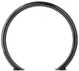
            - Height: 31 1/2 inches (80 cm)
            - Width: 35 1/2 inches (90.2 cm)
            - Weight: 32 lbs. (14.5 kg)
            - Design: Circle.
            - Metal: [Steel] [Stainless Steel].
            - Installation: [Concrete Insert, Surface/Flange Mount] [Concrete Embedded, In-ground Mount]
            - Color: [Textured black]

          - Reliance Foundry Model R-8226 [-SS]
            - Height: 35 1/2 inches (90.2 cm)
            - Width: 27 inches (68.6 cm)
            - Weight: 22 lbs. (10 kg)
            - Design: Circle.
            - Metal: [Steel] [Stainless Steel].
            - Installation: [Concrete Insert, Surface/Flange Mount] [Concrete Embedded, In-ground Mount]
            - Color: [Textured black]

          - Reliance Foundry Model R-8234
            - Height: 31 1/2 inches (80 cm)
            - Width: 35 1/2 inches (90.2 cm)
            - Weight: 32 lbs. (14.5 kg)
            - Design: Circle of square tubing.
            - Metal: [Steel]
            - Installation: [Concrete Insert, Surface/Flange Mount]
[Concrete Embedded, In-ground Mount]
            - Color: [Textured Black]

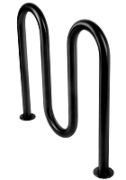
          - Reliance Foundry Model R-8239[-SS]
            - Height: 36 inches (91.4 cm)
            - Width: 39 inches (99 cm)
            - Weight: 45 lbs. (20.4 kg)
            - Design: Multi-Curve wave racks (3 curve).
            - Metal: [Steel] [Stainless Steel].
            - Installation: [Concrete Insert, Surface/Flange Mount] [Concrete Embedded, In-ground Mount]
            - Color: [Textured black]

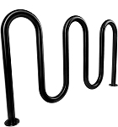
          - Reliance Foundry Model R-8240[-SS]
            - Height: 36 inches (91.4 cm)
            - Width: 63 1/2 inches (161.3 cm)
            - Weight: 63 lbs. (28.6 kg)
            - Design: Multi-Curve wave racks (5 curve).
            - Metal: [Steel] [Stainless Steel].
            - Installation: [Concrete Insert, Surface/Flange Mount] [Concrete Embedded, In-ground Mount]
            - Color: [Textured black]

          - Reliance Foundry Model R-8246[-SS]
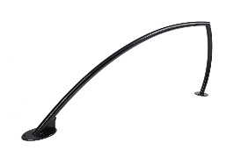
            - Height: 33 inches (83.8 cm)
            - Width: 59 inches (149.9 cm)
            - Weight: 25 lbs. (11.3 kg)
            - Design: Shark fin.
            - Metal: [Steel] [Stainless Steel].
            - Installation: [Surface/Flange Mount] [Concrete Embedded, In-ground Mount]
            - Color: [Textured black]
          - Reliance Foundry Model R-8241
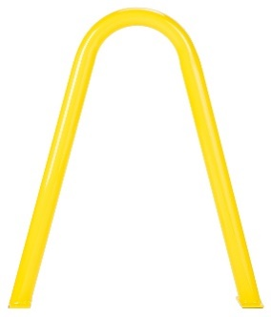
            - Height: 33 3/4 inches (85.7 cm)
            - Width: 26 5/8 inches (67.6 cm)
            - Weight: 23 lbs. (10.4 kg)
            - Design: Arched design.
            - Metal: [Steel]
            - Country of Origin: [USA]
            - Installation: [Concrete Insert, Flange Mount]
            - Color: [Red, Blue, Yellow, Green, Black]
          - Reliance Foundry Model R-8242
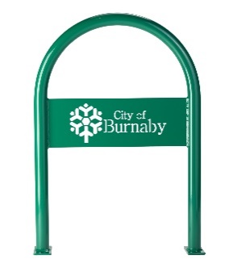
            - Height: 34 inches (86.36 cm)
            - Width: 24.48 inches (62.18 cm)
            - Weight: 25 lbs. (11.3 kg)
            - Design: Inverted U with custom plate.
            - Metal: [Steel]
            - Country of Origin: [USA]
            - Installation: [Concrete Insert, Flange Mount]
            - Color: [Red, Blue, Yellow, Green, Black]

          - Reliance Foundry Model R-8243
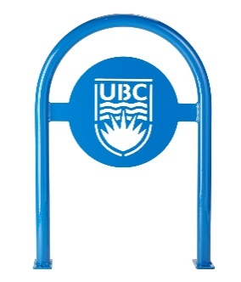
            - Height: 34 inches (86.36 cm)
            - Width: 24.48 inches (62.18 cm)
            - Weight: 26 lbs. (11.8 kg)
            - Design: Inverted U with custom plate.
            - Metal: [Steel]
            - Country of Origin: [USA]
            - Installation: [Concrete Insert, Flange Mount]
            - Color: [Red, Blue, Yellow, Green, Black]
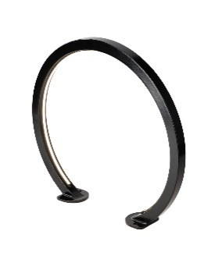
          - Reliance Foundry Model R-6234 Ferris
            - Height: 32 1/2 inches (82.6 cm)
            - Width: 35 1/2 inches (90.2 cm)
            - Weight: 27 lbs. (12.3 kg)
            - Design: Illuminated circle of square tubing.
            - Metal: [Steel]
            - Country of Origin: [China]
            - Installation: [Concrete Insert, Surface/Flange Mount]
            - Color: [Textured Black]
            - LED Driver: APV-16-24 LED
- Input Voltage: 120.0 VAC
- Input Current: 0.2677 A
- Input Power: 16.91 W
- Certifications: UL Certification
            - LED Light Output:
- Lumens: 666.8
- Color Temperature: 4000K

      - METALS
        - Steel:
          - Pipe: ASTM A53, Type F or Type S, Grade A.
          - Plate, Shapes and Bars: ASTM A36.
          - Recycled Content of Steel Products: Postconsumer recycled content plus one-half of preconsumer recycled content not less than 25 percent.
          - Powder-Coat Finish: AAMA 2603 except with a minimum dry film thickness of 1.5 mils. Comply with coating manufacturer's written instructions.
        - Stainless Steel: AISI Grade 316.
          - Pipe: ASTM A312.
          - Sheet, Strip, and Plate: ASTM A959.
          - Finish: Buffed Satin Finish No. 6.
      - ACCESSORIES
        - Mounting Accessories
          - Epoxy adhesive: As recommended in writing by adhesive manufacturer for outdoor use with concrete and steel.
          - Fasteners
            - [Standard: 1/2 inch UNC Button Head Bolts, c/w SS Washer.] [As specified.]
            - Drop in place concrete anchors, for 1/2 inch UNC bolts.
          - Sealant: Silicone elastomeric sealant recommended for outdoor use.
      - FABRICATION
        - Fabricate units with welded connections.
        - Fabricate connections that will be exposed to weather in a manner to exclude water. Provide weep holes where water may accumulate.
        - Provide inserts and other anchorage devices for connecting bicycle racks to substrate.
        - Protect finishes from damage before shipping.
        - Provide exposed [fasteners] [accessories] with stainless materials.
- EXECUTION
      - EXAMINATION
        - Examine paving or other substrates for compliance with manufacturer’s requirements for placement and location of embedded items, condition of substrate, and other conditions affecting installation of bicycle racks.
        - Proceed with installation only after unsatisfactory conditions have been corrected.
      - INSTALLATION
        - General: Comply with manufacturer’s installation requirements and setting drawings.
        - Install according to manufacturer's written instructions for specified setting method.
        - Do not install damaged, cracked, chipped, deformed or marred bicycle racks. Field touch-up minor imperfections in accordance with manufacturer’s instructions. Replace bicycle racks that cannot be field repaired.
      - CLEANING
        - Immediately prior to Substantial Completion, clean racks in accordance with manufacturer’s instructions to remove dust, dirt, adhesives, and other foreign materials.
      - PROTECTION
        - Protect bicycle racks against damage.

END OF SECTION
Copyright 2018 by Reliance Foundry Co. Ltd.; qualified design and construction professionals may copy for preparation of construction specifications and purchase orders for Reliance Foundry products.
Issued April 2018. Subject to change.

